Rhombohedron

Definition
# Source: AI Source: Provided by: [Data Path: Persons Table -> ID Column: 1, Name_En Column: Motasem Essam] -> From: [ChatGPT] on [7/25/2026]
A Rhombohedron is a three-dimensional polyhedron with six congruent rhombus-shaped faces. It is a special type of parallelepiped in which all six faces are rhombi.
It has:
- 6 congruent rhombus faces.
- 12 edges.
- 8 vertices.
- Opposite faces that are parallel.
- Three pairs of parallel opposite edges.
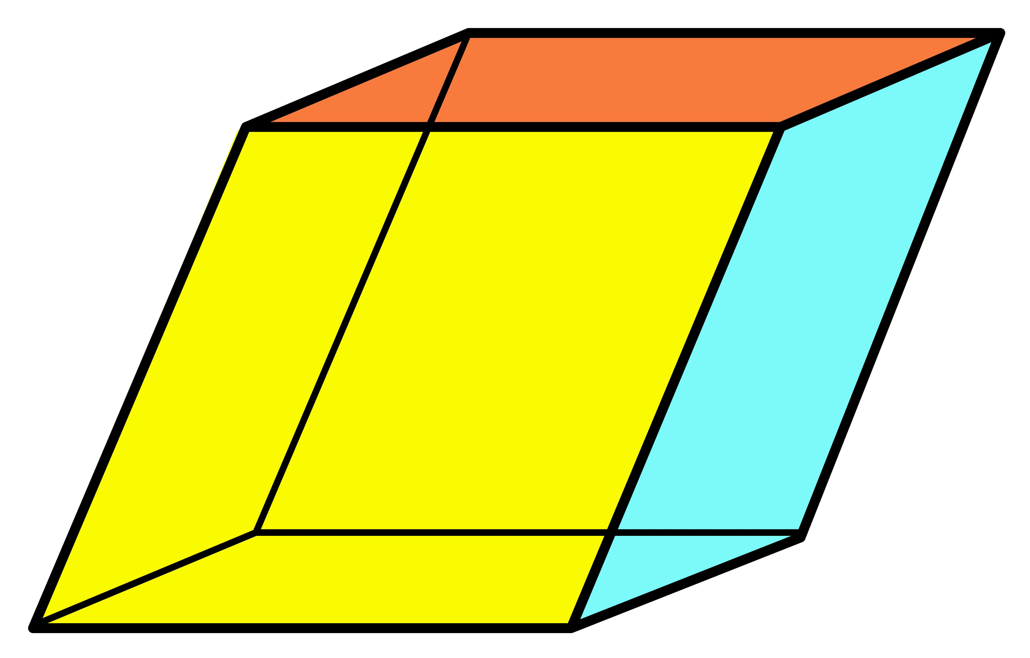

Simple Definition
# Source: AI Source: Provided by: [Data Path: Persons Table -> ID Column: 1, Name_En Column: Motasem Essam] -> From: [ChatGPT] on [7/25/2026]
A rhombohedron is a solid shape that looks like a slanted box whose six faces are identical rhombuses.
Unlike a cube, its faces are not necessarily squares, and its angles are not necessarily right angles.

Geometric Structure
# Source: AI Source: Provided by: [Data Path: Persons Table -> ID Column: 1, Name_En Column: Motasem Essam] -> From: [ChatGPT] on [7/25/2026]
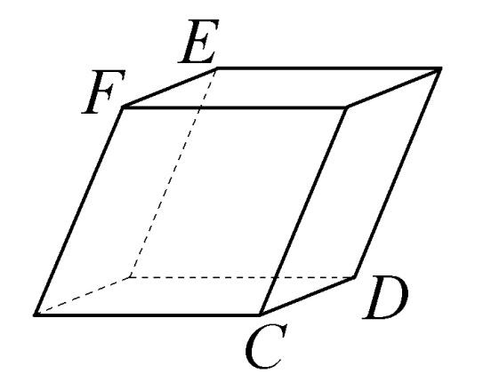
A rhombohedron consists of the following geometric elements:
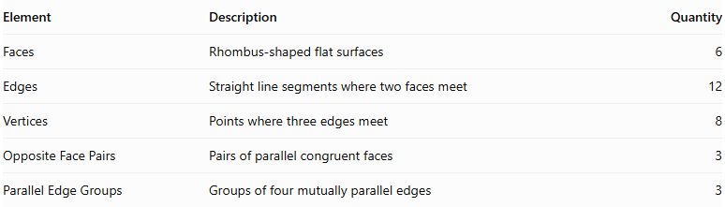
Element | Description | Quantity
Faces | Rhombus-shaped flat surfaces | 6
Edges | Straight line segments where two faces meet | 12
Vertices | Points where three edges meet | 8
Opposite Face Pairs | Pairs of parallel congruent faces | 3
Parallel Edge Groups | Groups of four mutually parallel edges | 3

Main Characteristics

A. Faces
# Source: AI Source: Provided by: [Data Path: Persons Table -> ID Column: 1, Name_En Column: Motasem Essam] -> From: [ChatGPT] on [7/25/2026]
All six faces of a rhombohedron are congruent rhombuses.
Each rhombus has:
- Four equal sides.
- Two pairs of parallel opposite sides.
- Opposite angles equal.
- Adjacent angles supplementary.
Important: A rhombohedron does not necessarily have six square faces.

B. Edges
# Source: AI Source: Provided by: [Data Path: Persons Table -> ID Column: 1, Name_En Column: Motasem Essam] -> From: [ChatGPT] on [7/25/2026]
A rhombohedron has 12 edges.
All 12 edges have the same length because all six faces are congruent rhombuses.
$$\boxed{E=12}$$

C. Vertices
# Source: AI Source: Provided by: [Data Path: Persons Table -> ID Column: 1, Name_En Column: Motasem Essam] -> From: [ChatGPT] on [7/25/2026]
A rhombohedron has 8 vertices.
Three edges meet at each vertex.
$$\boxed{V=8}$$

D. Opposite Faces
# Source: AI Source: Provided by: [Data Path: Persons Table -> ID Column: 1, Name_En Column: Motasem Essam] -> From: [ChatGPT] on [7/25/2026]
Each pair of opposite faces:
- Is parallel.
- Is congruent.
- Has the same orientation.
There are three pairs of opposite faces.

Mathematical Properties

A. Euler's Polyhedron Formula
# Source: AI Source: Provided by: [Data Path: Persons Table -> ID Column: 1, Name_En Column: Motasem Essam] -> From: [ChatGPT] on [7/25/2026]
For a convex rhombohedron:
$$V-E+F=2$$
Substituting:
$$8-12+6=2$$
Therefore, Euler's formula is satisfied.

B. Surface Area
# Source: AI Source: Provided by: [Data Path: Persons Table -> ID Column: 1, Name_En Column: Motasem Essam] -> From: [ChatGPT] on [7/25/2026]
Because all six faces are congruent rhombuses:
$$\boxed{SA=6A_{r}}$$
The area of one rhombus is:
$$A_{r}=bh$$
Where:
- $b$ = base length of the rhombus.
- $h$ = perpendicular height of the rhombus.
Therefore:
$$\boxed{SA=6bh}$$
Alternatively, using the diagonals $d_{1}$ and $d_{2}$:
$$A_{r}=\frac{d_{1}d_{2}}{2}$$
Thus:
$$\boxed{SA=3d_{1}d_{2}}$$

C. Volume
# Source: AI Source: Provided by: [Data Path: Persons Table -> ID Column: 1, Name_En Column: Motasem Essam] -> From: [ChatGPT] on [7/25/2026]
A rhombohedron is a parallelepiped, so its volume is:
$$\boxed{V=Bh}$$
Where:
- $B$ = area of the base rhombus.
- $h$ = perpendicular distance between the two opposite base faces.
Since $B={bh}_{r}$, where $h_{r}$ is the rhombus's perpendicular face height:
$$\boxed{V={bh}_{rH}}$$
Here, $H$ is the perpendicular height of the solid.

D. Volume Using Three Edge Vectors
# Source: AI Source: Provided by: [Data Path: Persons Table -> ID Column: 1, Name_En Column: Motasem Essam] -> From: [ChatGPT] on [7/25/2026]
For a rhombohedron with three edge lengths $a,b,c$ and inter-edge angles $α,β,γ$:
$$V=abc\sqrt{1+2cosαcosβcosγ-\cos^{2}α-\cos^{2}β-\cos^{2}γ}$$
For a rhombohedron, $a=b=c$, so:
$$\boxed{V=a^{3}\sqrt{1+2cosαcosβcosγ-\cos^{2}α-\cos^{2}β-\cos^{2}γ}}$$

Types of Rhombohedra
# Source: AI Source: Provided by: [Data Path: Persons Table -> ID Column: 1, Name_En Column: Motasem Essam] -> From: [ChatGPT] on [7/25/2026]
Rhombohedra can be classified according to their face angles and spatial arrangement.

A. Acute Rhombohedron
# Source: AI Source: Provided by: [Data Path: Persons Table -> ID Column: 1, Name_En Column: Motasem Essam] -> From: [ChatGPT] on [7/25/2026]
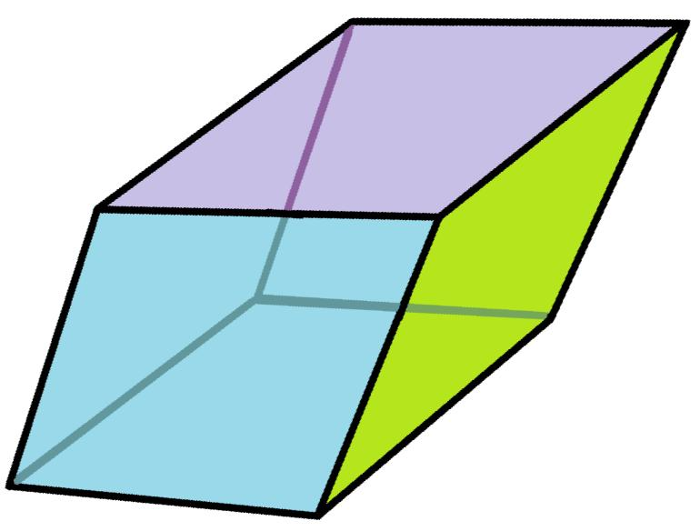
An acute rhombohedron has rhombus faces with all three crystallographic inter-edge angles acute.

B. Obtuse Rhombohedron
# Source: AI Source: Provided by: [Data Path: Persons Table -> ID Column: 1, Name_En Column: Motasem Essam] -> From: [ChatGPT] on [7/25/2026]
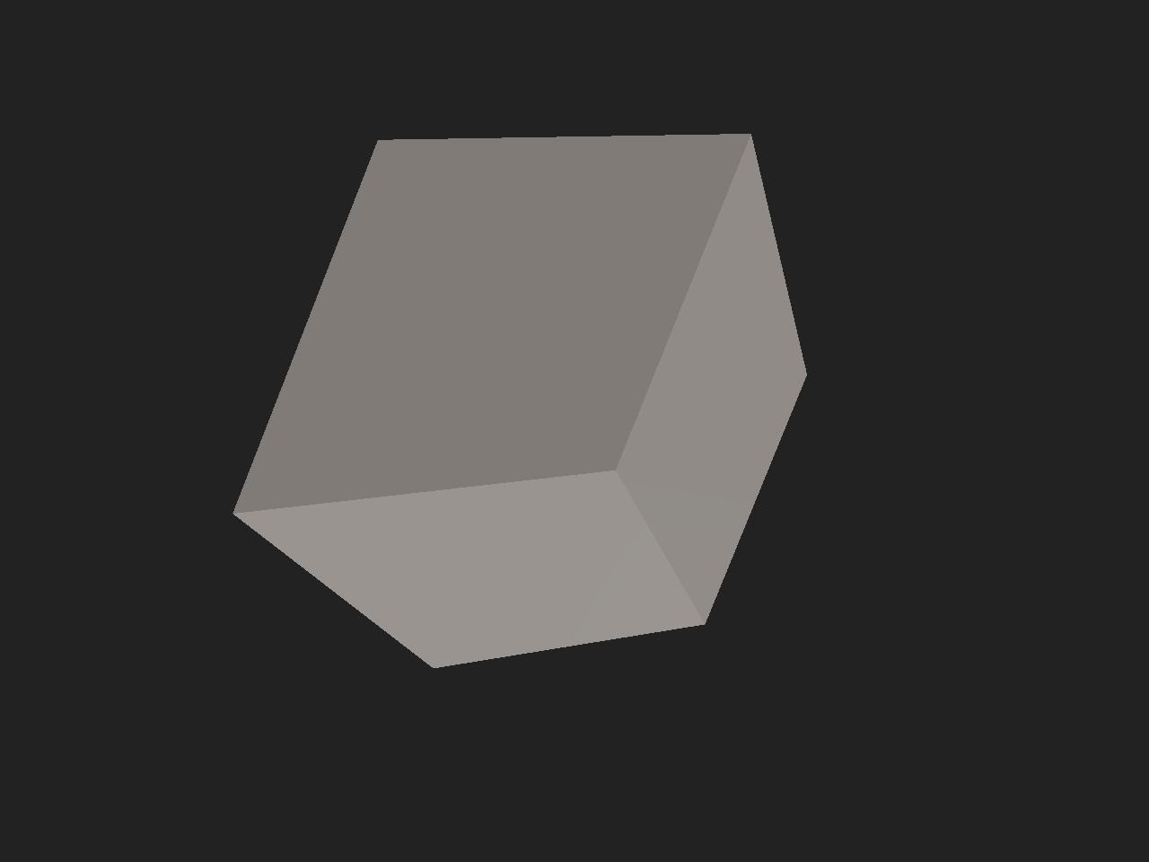
An obtuse rhombohedron has three crystallographic inter-edge angles that are obtuse.

C. Right Rhombohedron
# Source: AI Source: Provided by: [Data Path: Persons Table -> ID Column: 1, Name_En Column: Motasem Essam] -> From: [ChatGPT] on [7/25/2026]
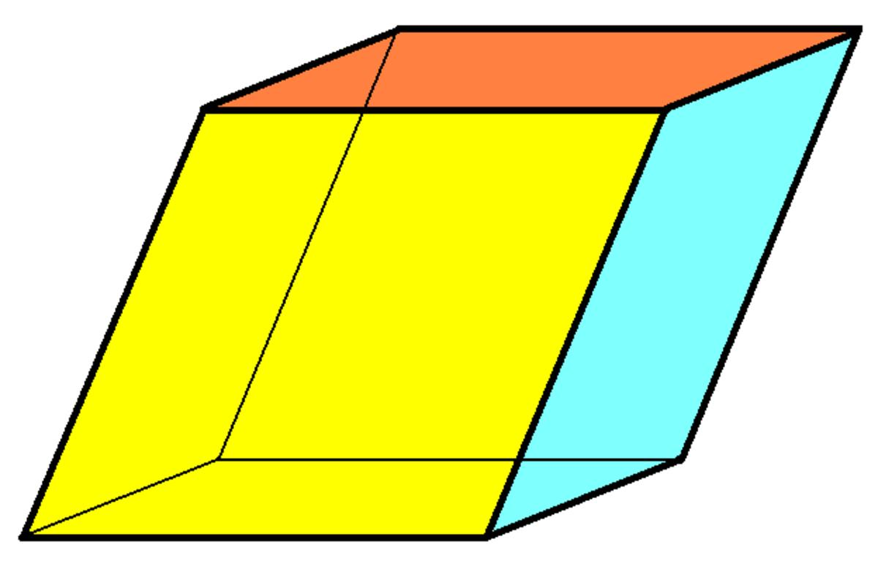
A right rhombohedron has three mutually perpendicular edge directions.
Important distinction: A parallelepiped with three perpendicular edge directions is a rectangular prism. If all its edges are equal, it is a cube. Therefore, the right rhombohedron is a special limiting case rather than a distinct non-cubic shape.

Relationship with Other Geometric Solids
# Source: AI Source: Provided by: [Data Path: Persons Table -> ID Column: 1, Name_En Column: Motasem Essam] -> From: [ChatGPT] on [7/25/2026]
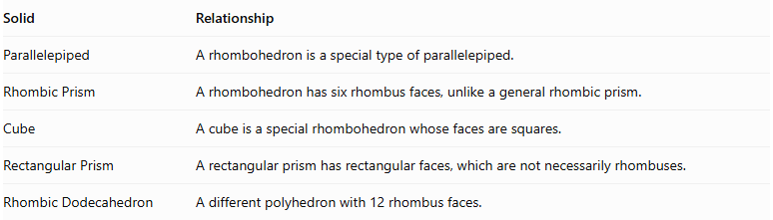
Solid | Relationship
Parallelepiped | A rhombohedron is a special type of parallelepiped.
Rhombic Prism | A rhombohedron has six rhombus faces, unlike a general rhombic prism.
Cube | A cube is a special rhombohedron whose faces are squares.
Rectangular Prism | A rectangular prism has rectangular faces, which are not necessarily rhombuses.
Rhombic Dodecahedron | A different polyhedron with 12 rhombus faces.
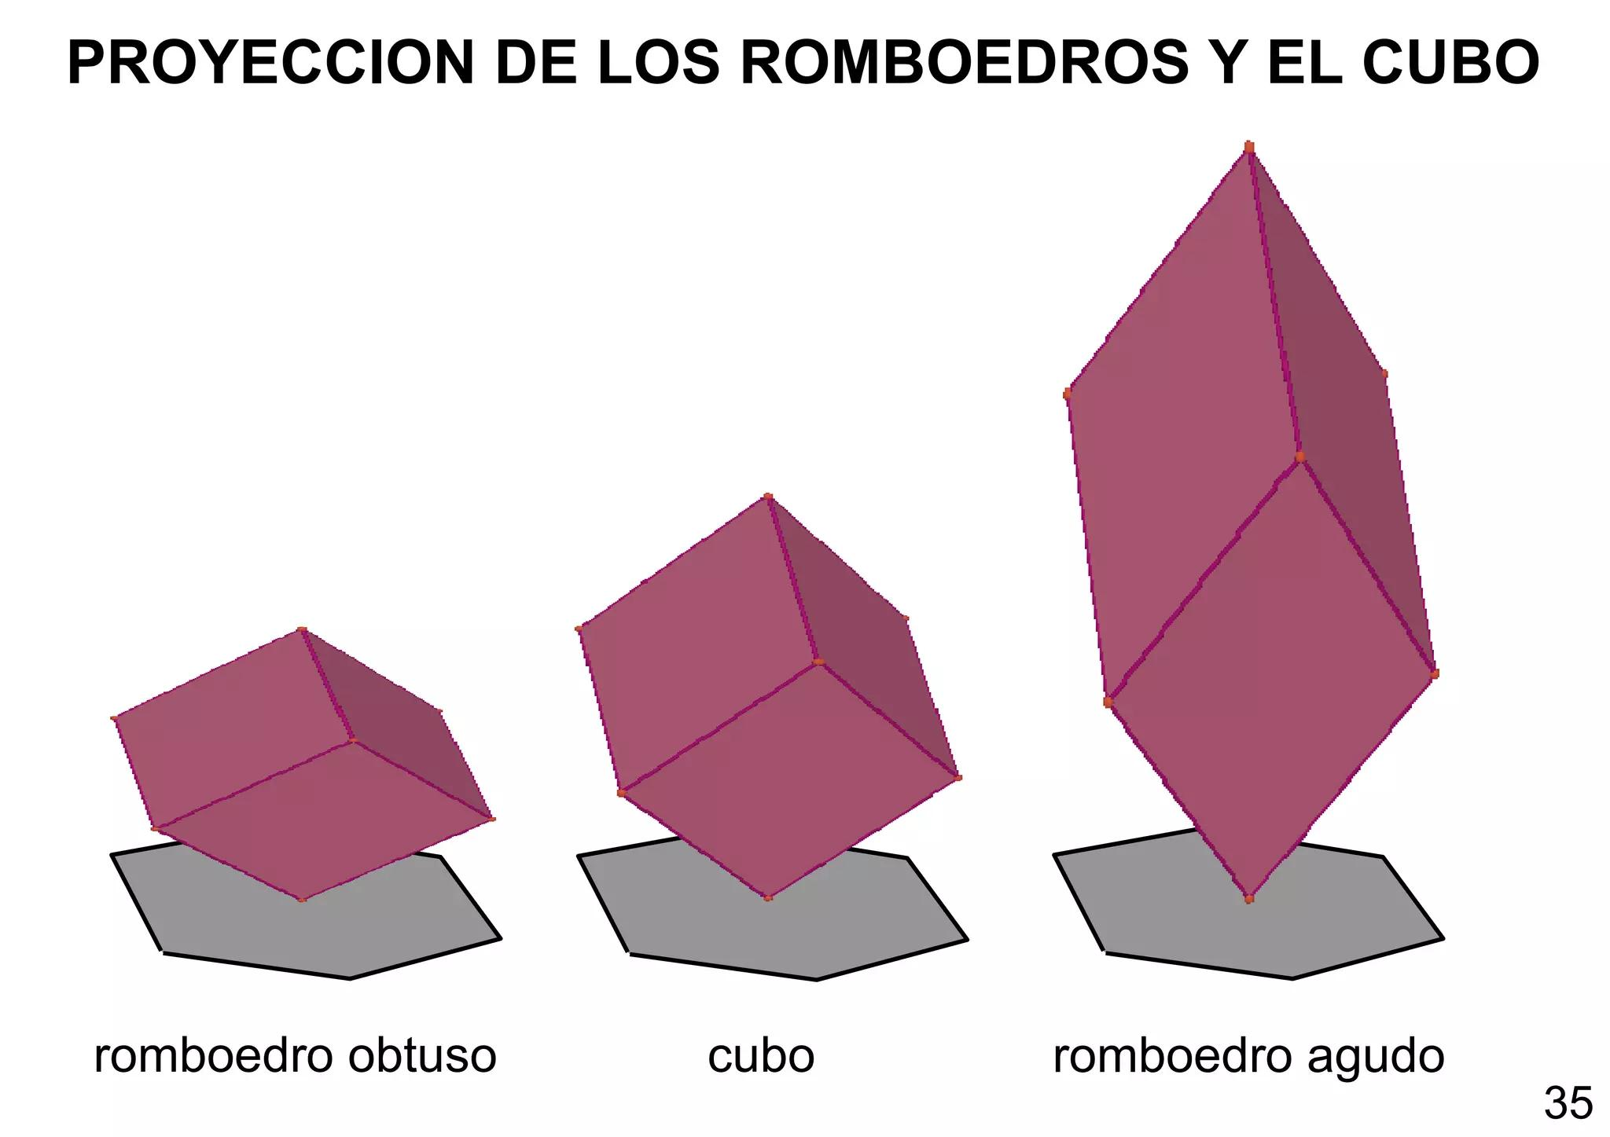

Worked Mathematical Examples

Example 1: Surface Area
# Source: AI Source: Provided by: [Data Path: Persons Table -> ID Column: 1, Name_En Column: Motasem Essam] -> From: [ChatGPT] on [7/25/2026]
A rhombohedron has rhombus faces with a base length of $6 cm$ and perpendicular face height of $4 cm$.
Find its total surface area.
Solution:
Area of one face:
$$A_{r}=bh$$
$$A_{r}=6×4=24{ cm}^{2}$$
Total surface area:
$$SA=6A_{r}$$
$$SA=6×24$$
$$\boxed{SA=144{ cm}^{2}}$$

Example 2: Volume
# Source: AI Source: Provided by: [Data Path: Persons Table -> ID Column: 1, Name_En Column: Motasem Essam] -> From: [ChatGPT] on [7/25/2026]
A rhombohedron has a base rhombus with an area of $30{ cm}^{2}$ and a perpendicular height of $10 cm$.
Find its volume.
Solution:
$$V=Bh$$
$$V=30×10$$
$$\boxed{V=300{ cm}^{3}}$$

Symmetry Properties
# Source: AI Source: Provided by: [Data Path: Persons Table -> ID Column: 1, Name_En Column: Motasem Essam] -> From: [ChatGPT] on [7/25/2026]
A general rhombohedron has:
- A center of symmetry at the intersection of its body diagonals.
- Three pairs of opposite parallel faces.
- Three pairs of opposite vertices.
- Central inversion symmetry.
However, a general rhombohedron does not necessarily have mirror symmetry planes.

Constructing Rhombohedron in Solid Geometry

Instruments Used
# Source: AI Source: Provided by: [Data Path: Persons Table -> ID Column: 1, Name_En Column: Motasem Essam] -> From: [ChatGPT] on [7/25/2026]
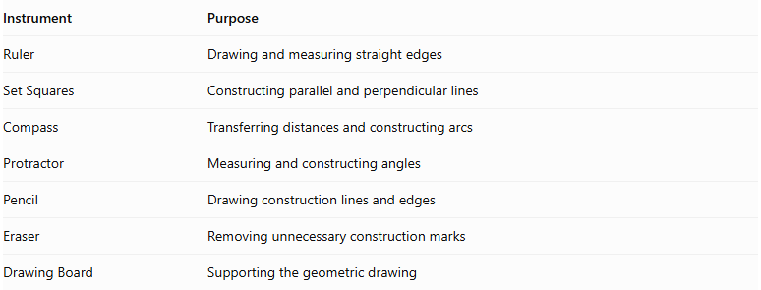
Instrument | Purpose
Ruler | Drawing and measuring straight edges
Set Squares | Constructing parallel and perpendicular lines
Compass | Transferring distances and constructing arcs
Protractor | Measuring and constructing angles
Pencil | Drawing construction lines and edges
Eraser | Removing unnecessary construction marks
Drawing Board | Supporting the geometric drawing

Construction Procedures

Face-Based Construction
# Source: AI Source: Provided by: [Data Path: Persons Table -> ID Column: 1, Name_En Column: Motasem Essam] -> From: [ChatGPT] on [7/25/2026]
- Determine the edge length and interior angles of the rhombus faces.
- Draw a rhombus representing the front face.
- Construct a second congruent rhombus representing an adjacent face.
- Ensure that the shared edge has the same length in both faces.
- Continue constructing the remaining rhombus faces.
- Connect the corresponding vertices.
- Verify that all six faces are congruent rhombi.
- Complete the visible and hidden edges.

Edge-Based Construction
# Source: AI Source: Provided by: [Data Path: Persons Table -> ID Column: 1, Name_En Column: Motasem Essam] -> From: [ChatGPT] on [7/25/2026]
- Determine the common edge length.
- Draw three edges extending from one common vertex.
- Construct the required spatial angles between the three edges.
- Draw parallel edges through their endpoints.
- Complete the remaining edges by connecting corresponding endpoints.
- Verify that all twelve edges have equal lengths.
- Check that opposite edges are parallel.
- Complete the six rhombus faces.

Base-Based Construction
# Source: AI Source: Provided by: [Data Path: Persons Table -> ID Column: 1, Name_En Column: Motasem Essam] -> From: [ChatGPT] on [7/25/2026]
- Draw a rhombus representing the base.
- Determine the required perpendicular height and lateral orientation.
- Draw four equal and parallel lateral edges from the base vertices.
- Construct the opposite rhombus using the corresponding endpoints.
- Complete the four lateral rhombus faces.
- Verify that all six faces are congruent.
- Refine the final solid representation.

Diagonal-Based Face Construction
# Source: AI Source: Provided by: [Data Path: Persons Table -> ID Column: 1, Name_En Column: Motasem Essam] -> From: [ChatGPT] on [7/25/2026]
- Determine the two diagonals of the required rhombus.
- Draw the first diagonal.
- Construct its perpendicular bisector using a ruler and compass.
- Mark the endpoints of the second diagonal.
- Connect the four endpoints to form the rhombus.
- Repeat the process to construct congruent rhombus faces.
- Join the faces along corresponding edges.
- Complete the three-dimensional representation.

Net-Based Construction
# Source: AI Source: Provided by: [Data Path: Persons Table -> ID Column: 1, Name_En Column: Motasem Essam] -> From: [ChatGPT] on [7/25/2026]
- Draw six congruent rhombi.
- Arrange them in a connected net that allows the faces to fold into a closed solid.
- Ensure that every shared boundary has the same length.
- Add tabs if the net will be assembled physically.
- Cut out the net.
- Fold along the edges.
- Join the corresponding boundaries to form the rhombohedron.
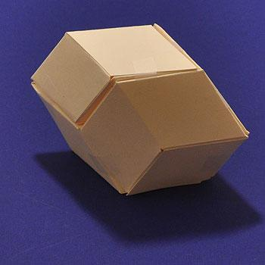

Real-World Applications
# Source: AI Source: Provided by: [Data Path: Persons Table -> ID Column: 1, Name_En Column: Motasem Essam] -> From: [ChatGPT] on [7/25/2026]
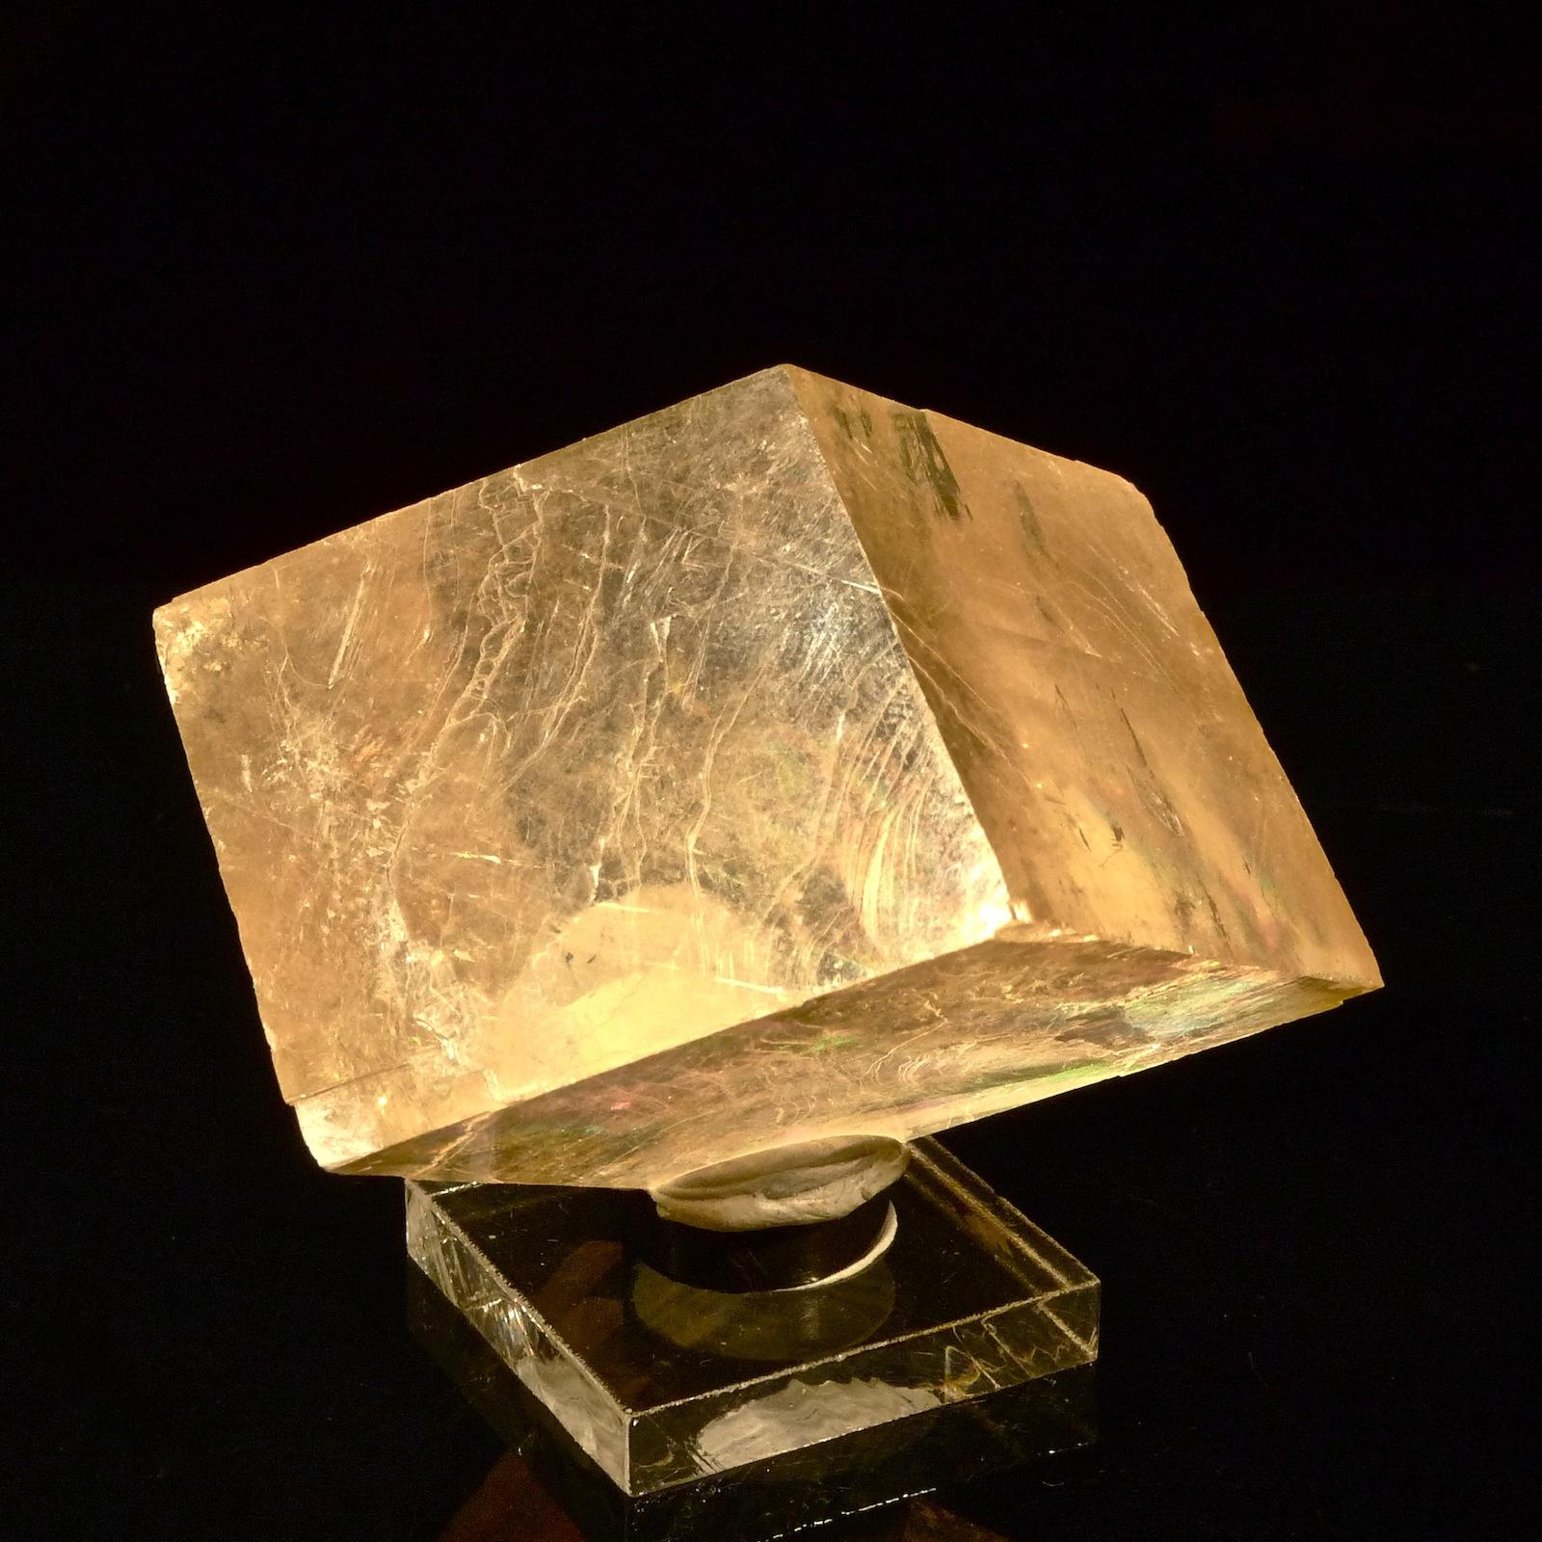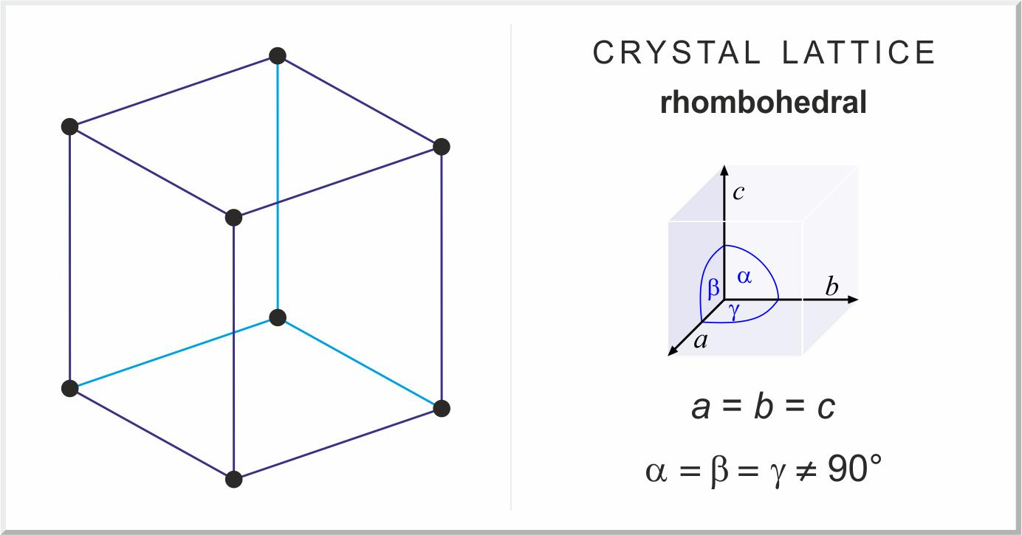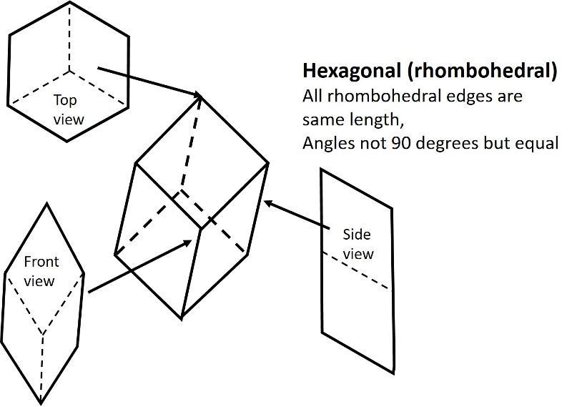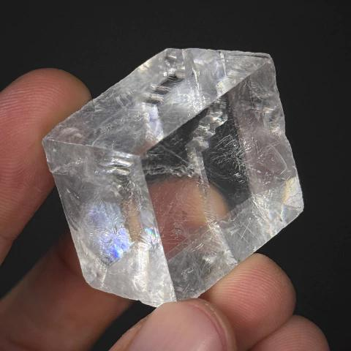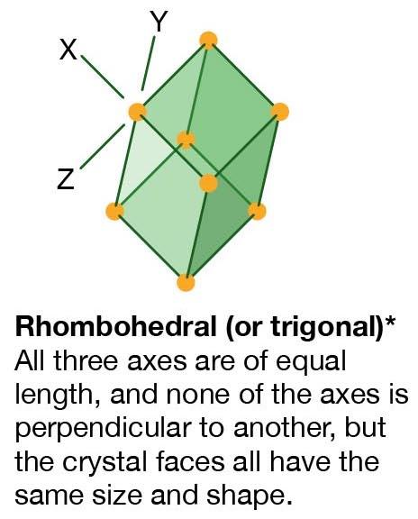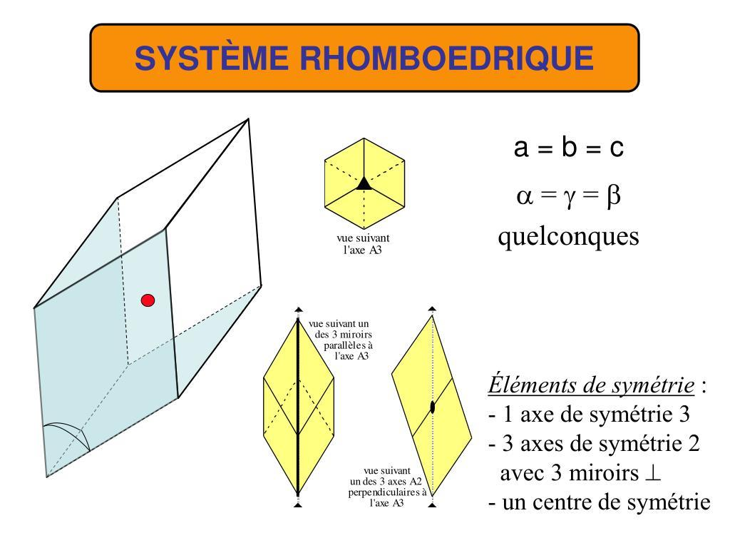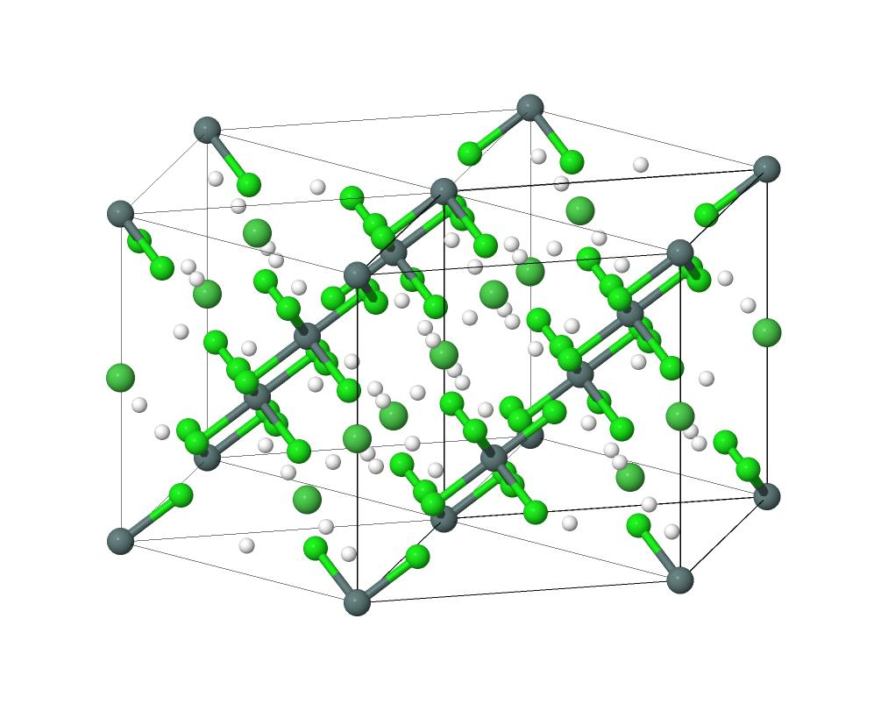
Rhombohedra are particularly important in crystallography and mineralogy.
Examples include:
- Calcite Crystals: Calcite commonly forms rhombohedral crystal shapes.
- Crystallography: Rhombohedral unit cells describe certain crystal structures.
- Mineralogy: Used to classify and describe mineral crystal forms.
- Geometric Modeling: Used in three-dimensional geometry and solid modeling.

Key Points
# Source: AI Source: Provided by: [Data Path: Persons Table -> ID Column: 1, Name_En Column: Motasem Essam] -> From: [ChatGPT] on [7/25/2026]
- A rhombohedron is a special type of parallelepiped.
- It has six congruent rhombus-shaped faces.
- It has 12 equal edges and 8 vertices.
- Opposite faces are parallel.
- Three edges meet at every vertex.
- Its surface area is six times the area of one rhombus face.
- Its volume equals the base area multiplied by the perpendicular height.
- A cube is a special case of a rhombohedron.
- Rhombohedra are important in crystallography and mineralogy.

Conclusion
# Source: AI Source: Provided by: [Data Path: Persons Table -> ID Column: 1, Name_En Column: Motasem Essam] -> From: [ChatGPT] on [7/25/2026]
A Rhombohedron is a six-faced three-dimensional polyhedron characterized by six congruent rhombus faces, 12 equal edges, and 8 vertices. As a special type of parallelepiped, it has three pairs of parallel opposite faces and a volume determined by its base area and perpendicular height. Rhombohedra are particularly significant in crystallography, where they describe the shapes and structural arrangements of various minerals.

